**[What’s the Difference Between GPT and MBR When Partitioning a Drive?](http://www.howtogeek.com/193669/whats-the-difference-between-gpt-and-mbr-when-partitioning-a-drive/" \o "What’s the Difference Between GPT and MBR When Partitioning a Drive?)**

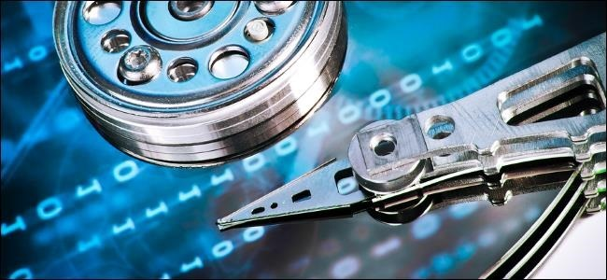

[Set up a new disk on Windows 8.x or 10](http://www.howtogeek.com/school/using-windows-admin-tools-like-a-pro/lesson4/) and you’ll be asked whether you want to use MBR or GPT. GPT is the new standard and is gradually replacing MBR.

GPT brings with it many advantages, but MBR is still the most compatible and is still necessary in some cases. This isn’t a Windows-only standard — Mac OS X, Linux, and other operating systems can also use GPT.

**What Do GPT and MBR Do?**

RELATED ARTICLE

**[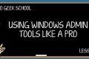](http://www.howtogeek.com/school/using-windows-admin-tools-like-a-pro/lesson4/)**

[**Understanding Hard Drive Partitioning with Disk Management**](http://www.howtogeek.com/school/using-windows-admin-tools-like-a-pro/lesson4/)  
In today’s edition of Geek School, we’re going to talk about how to use Disk Management… but we’re going to... [[Read Article]](http://www.howtogeek.com/193669/whats-the-difference-between-gpt-and-mbr-when-partitioning-a-drive/)

[You have to partition a disk drive before you can use it](http://www.howtogeek.com/184659/beginner-geek-hard-disk-partitions-explained/). MBR (Master Boot Record) and GPT (GUID Partition Table) are two different ways of storing the partitioning information on a drive. This information includes where partitions start and begin, so your operating system knows which sectors belong to each partition and which partition is bootable. This is why you have to choose MBR or GPT before creating partitions on a drive.

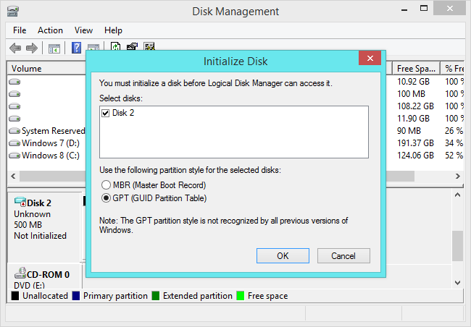

**MBR’s Limitations**

RELATED ARTICLE

**[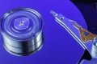](http://www.howtogeek.com/184659/beginner-geek-hard-disk-partitions-explained/)**

[**Beginner Geek: Hard Disk Partitions Explained**](http://www.howtogeek.com/184659/beginner-geek-hard-disk-partitions-explained/)  
Hard disks, USB drives, SD cards — anything with storage space must be partitioned. An unpartitioned drive can’t be used... [[Read Article]](http://www.howtogeek.com/184659/beginner-geek-hard-disk-partitions-explained/)

MBR standards for Master Boot Record. It was introduced with IBM PC DOS 2.0 in 1983.

It’s called Master Boot Record because the MBR is a special boot sector located at the beginning of a drive. This sector contains a boot loader for the installed operating system and information about the drive’s logical partitions. The boot loader is a small bit of code that generally loads the larger boot loader from another partition on a drive. If you have Windows installed, the initial bits of [the Windows boot loader](http://www.howtogeek.com/192772/what-is-the-system-reserved-partition-and-can-you-delete-it/) reside here — that’s why you may have to [repair your MBR](http://www.howtogeek.com/howto/32523/how-to-manually-repair-windows-7-boot-loader-problems/) if it’s overwritten and Windows won’t boot. If you have Linux installed, [the GRUB boot loader](http://www.howtogeek.com/114884/how-to-repair-grub2-when-ubuntu-wont-boot/) will typically be located in the MBR.

MBR works with disks up to 2 TB in size, but it can’t handle disks with more than 2 TB of space. MBR also only supports up to four primary partitions — if you want more, you have to make one of your primary partitions an “extended partition” and create logical partitions inside it. This is a silly little hack and shouldn’t be necessary.

MBR became the industry standard everyone used for partitioning and booting from disks. Developers have been piling on hacks like extended partitions ever since.

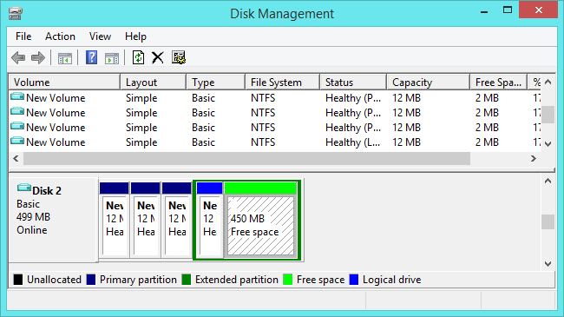

**GPT’s Advantages**

RELATED ARTICLE

**[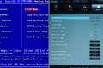](http://www.howtogeek.com/56958/htg-explains-how-uefi-will-replace-the-bios/)**

[**HTG Explains: Learn How UEFI Will Replace Your PC’s BIOS**](http://www.howtogeek.com/56958/htg-explains-how-uefi-will-replace-the-bios/)  
While most people may be familiar with a PC’s BIOS, they may not know what it is or what it... [[Read Article]](http://www.howtogeek.com/56958/htg-explains-how-uefi-will-replace-the-bios/)

GPT stands for GUID Partition Table. It’s a new standard that’s gradually replacing MBR. It’s associated with UEFI — [UEFI replaces the clunky old BIOS with something more modern](http://www.howtogeek.com/56958/), and GPT replaces the clunky old MBR partitioning system with something more modern. It’s called GUID Partition Table because every partition on your drive has a “globally unique identifier,” or GUID — a random string so long that every GPT partition on earth likely has its own unique identifier.

This system doesn’t have MBR’s limits. Drives can be much, much larger and size limits will depend on the operating system and its file systems. GPT allows for a nearly unlimited amount of partitions, and the limit here will be your operating system — Windows allows up to 128 partitions on a GPT drive, and you don’t have to create an extended partition.

On an MBR disk, the partitioning and boot data is stored in one place. If this data is overwritten or corrupted, you’re in trouble. In contrast, GPT stores multiple copies of this data across the disk, so it’s much more robust and can recover if the data is corrupted. GPT also stores cyclic redundancy check (CRC) values to check that its data is intact — if the data is corrupted, GPT can notice the problem and attempt to recover the damaged data from another location on the disk. MBR had no way of knowing if its data was corrupted — you’d only see there was a problem when the boot process failed or your drive’s partitions vanished.

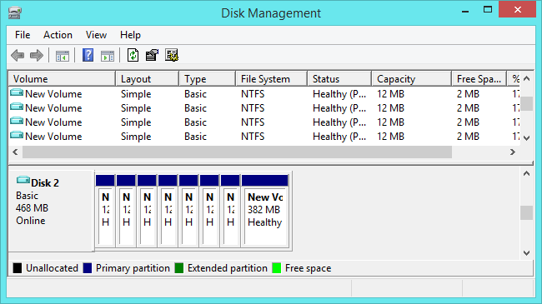

**Compatibility**

GPT drives tend to include a “protective MBR.” This type of MBR says that the GPT drive has a single partition that extends across the entire drive. If you try to manage a GPT disk with an old tool that can only read MBRs, it will see a single partition that extends across the entire drive. The MBR ensures the old tools won’t mistake the GPT drive for an unpartitioned drive and overwrite its GPT data with a new MBR. In other words, the protective MBR protects the GPT data from being overwritten.

Windows can only boot from GPT on UEFI-based computers running 64-bit versions of Windows 10, 8.1, 8, 7, Vista, and corresponding server versions. All versions of Windows 10, 8.1, 8, 7, and Vista can read GPT drives and use them for data — they just can’t boot from them without UEFI.

Other modern operating systems can also use GPT. Linux has built-in support for GPT. Apple’s Intel Macs no longer use Apple’s APT (Apple Partition Table) scheme and use GPT instead.

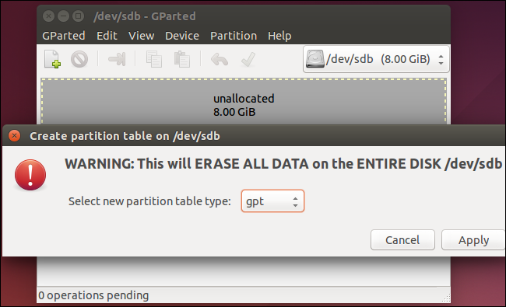

You’ll probably want to use GPT when setting up a drive. It’s a more modern, robust standard that all computers are moving toward. If you need compatibility with old systems — for example, the ability to boot Windows off a drive on a computer with a traditional BIOS — you’ll have to stick with MBR for now.